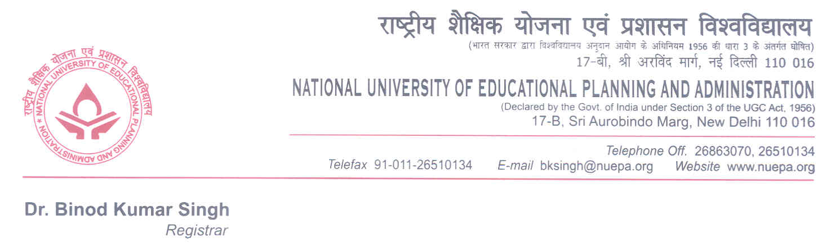
F.No.11-2/2012-13/AA
Thursday, June 28, 2012

Mr. Souvik Mukherjee
253-A/1, Birbal Tokas Apartment,
Munirka Opp. JNU Campus,
New Delhi

Subject: Offer of Provisional Admission to Full-Time Ph.D. Programme-2012

Dear candidate,

With reference to the FGPA obtained by you at the M.Phil. Examination held in May-June 2012, at this University and the subsequent interview you had appeared on 26.6.2012 relating admission to Full-Time Ph.D. Programme of this University; we are pleased to inform you that you have been permitted provisional admission to the said course with fellowships of this University with the following terms and conditions:

- You are required to report in Room No. 003 on 10 July, 2012 at 10.00 A.M. at this University along with following documents in original with one set of certified copies thereof:

  - Degree/Certificate & Marks-sheet in support of having passed Bachelor & Master degrees as claimed by you in your application.

  - Certificate of Secondary School Examinations showing date of birth.

  - Two copies of recent self-attested photographs duly signed

  - Undertakings on prescribed format as required under item Nos.4 & 5 of this letter

  - NOC from employer, if employed

  - Certificate issued by competent authority if you belong to SC/ST/OBC/PWD (Persons with Disabilities) categories.

Contd…2/
- 2 -

- Payment of Fees – While reporting for admission, you are also required to bring the following payments in the form of a Bank Demand Draft drawn in favour of NUEPA payable at Delhi.

S.No. | Item of Fee | Amount Payable
1. | Admission | Rs.3000.00

Refundable Deposit

1. | Library Fee | Rs.2000.00
2. | Computer Centre Fee | Rs.2000.00
 | Total | Rs.4000.00
 | Grand Total | 3000+4000 = Rs. 7000.00

Programme Fee of Rs.1500.00 (Payable per annum by all M.Phil and Ph.D. scholars from second year onwards)

- The amount of fellowship payable to you during the course will be Rs.12000/- per month.

- You are further required to submit an undertaking that you are not registered for pursuing any other full-time/part-time programme of study in any other University/Institution and that you are not getting any Fellowship/scholarship/financial assistance as on date from any other organization.

- You are also required to submit an undertaking on the enclosed prescribed format, duly signed and completed, towards observance of proper discipline, conduct and decorum during the period of your studentship at NUEPA.

- If you are employed, you are requested to produce a No Objection Certificate along with sanction letter for leave and relief from duties issued by your employer, failing which you will not be permitted to take admission to the said course and this offer of admission shall stand cancelled and withdrawn.

- If you have qualified NET and JRF through UGC/ICSSR, you will draw the Fellowship from concerned organizations through the National University as per the norms and procedures laid down by the said organizations.

- You are also advised to submit affidavits regarding “UGC Regulations on “Curbing the Menace of Ragging in Higher Educational Institutions, 2009”, on non-judicial stamp papers of Rs.10/- value, as per the enclosed formats. The affidavits are required to be submitted separately by the student and parents/guardian. A copy of the above regulations may be downloaded/seen from the UGC website www.ugc.ac.in, if desired.

Contd…3/-

- 3 -

- The continuation of the Fellowship of NUEPA shall be subject to submission of satisfactory progress report of the student duly approved by the supervisor in each quarter. The Fellowship is payable only from the date of starting of the course and during the course period if otherwise eligible.

- The University may provide residential accommodation at its residential flats at Bindapur, Dwarka, New Delhi, subject to its availability.

- If this offer of provisional admission with its all terms and conditions is acceptable to you, you are required to return the duplicate copy of this offer letter duly accepted and signed by you (in the space given below) latest by 10 July 2012, failing which it will be presumed that you are not interested to take admission to the said course and this offer shall automatically stand withdrawn and cancelled.

- Please note that the session for the above course shall be starting from July 16, 2012 at 10.00 A.M.

Thanking you,

Yours sincerely,

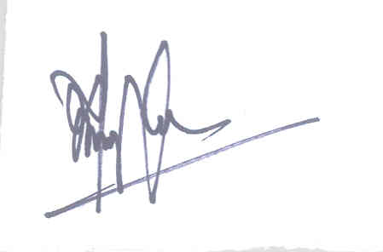
(REGISTRAR)

______________________________________________________________________________

I, the undersigned, hereby accept all the terms and conditions mentioned above.

Signature of the candidate:__________________________________

Date:______________________________________
UNDERTAKING

(To be submitted by the candidate seeking admission to Ph.D. Programme 2012-13)

(Condition No.4 of the Letter dated 28.06.2012 refers)

I, the undersigned, hereby solemnly undertake that I am not registered for pursuing any other full-time/part-time programme/study in any other University/Institution and that I am not receiving any Fellowship/Scholarship/financial assistance as on date from any other organization.

Name of the Candidate:__________________________________ Ref. No._______________

Signature:__________________________________

Date:______________________________________

Signature of the Parent/Guardian/Witness: ________________________________________

Name:_________________________________________
Address:_______________________________________
________________________________________
UNDERTAKING

(To be submitted by the candidate seeking admission to Ph.D. Programme 2012-13)

(Condition No.5 of the Letter dated 28.06.2012 refers)

I, the undersigned hereby solemnly undertake as under:
- That I shall observe and abide by all the rules and regulations governing my studentship and admission to Ph.D. Programme 2012-13 of NUEPA.
- I shall maintain proper discipline, conduct and decorum during the period of my studentship at NUEPA.
- I shall use the books/equipment of NUEPA with due care and caution which may become accessible to me during my studentship period at NUEPA.
- I shall not indulge in any act which may be prejudicial to the interest of NUEPA and subversive of discipline at NUEPA.

Name of the Candidate:__________________________________ Ref. No._______________

Signature:__________________________________

Date:______________________________________

Signature of the Parent/Guardian/Witness: ________________________________________

Name:_________________________________________
Address:_______________________________________
________________________________________

ANNEXURE I
AFFIDAVIT BY THE STUDENT

I, (full name of student with admission/registration/enrolment number) s/o d/o Mr./Mrs./Ms. ___________________________________________ , having been admitted to (name of the institution) , have received a copy of the UGC Regulations on Curbing the Menace of Ragging in Higher Educational Institutions, 2009, (hereinafter called the “Regulations”) carefully read and fully understood the provisions contained in the said Regulations.

2) I have, in particular, perused clause 3 of the Regulations and am aware as to what constitutes ragging.

3) I have also, in particular, perused clause 7 and clause 9.1 of the Regulations and am fully aware of the penal and administrative action that is liable to be taken against me in case I am found guilty of or abetting ragging, actively or passively, or being part of a conspiracy to promote ragging.

4) I hereby solemnly aver and undertake that

a) I will not indulge in any behaviour or act that may be constituted as ragging under clause 3 of the Regulations.

b) I will not participate in or abet or propagate through any act of commission or omission that may be constituted as ragging under clause 3 of the Regulations.

5) I hereby affirm that, if found guilty of ragging, I am liable for punishment according to clause 9.1 of the Regulations, without prejudice to any other criminal action that may be taken against me under any penal law or any law for the time being in force.

6) I hereby declare that I have not been expelled or debarred from admission in any institution in the country on account of being found guilty of, abetting or being part of a conspiracy to promote, ragging; and further affirm that, in case the declaration is found to be untrue, I am aware that my admission is liable to be cancelled.

Declared this ___day of __________ month of ______year.
________________
Signature of deponent
Name:
VERIFICATION

Verified that the contents of this affidavit are true to the best of my knowledge and no part of the affidavit is false and nothing has been concealed or misstated therein.

Verified at (place) on this the (day) of (month), (year ) .
________________
Signature of deponent

Solemnly affirmed and signed in my presence on this the (day) of (month), (year) after reading the contents of this affidavit.
OATH COMMISSIONER
ANNEXURE II
AFFIDAVIT BY PARENT/GUARDIAN

I, Mr./Mrs./Ms. _____________________________________________________ (full name of parent/guardian) father/mother/guardian of, (full name of student with admission/registration/enrolment number), having been admitted to____ (name of the institution), have received a copy of the UGC Regulations on Curbing the Menace of Ragging in Higher Educational Institutions, 2009, (hereinafter called the “Regulations”), carefully read and fully understood the provisions contained in the said Regulations.

2) I have, in particular, perused clause 3 of the Regulations and am aware as to what constitutes ragging.

3) I have also, in particular, perused clause 7 and clause 9.1 of the Regulations and am fully aware of the penal and administrative action that is liable to be taken against my ward in case he/she is found guilty of or abetting ragging, actively or passively, or being part of a conspiracy to promote ragging.

4) I hereby solemnly aver and undertake that

a) My ward will not indulge in any behaviour or act that may be constituted as ragging under clause 3 of the Regulations.

b) My ward will not participate in or abet or propagate through any act of commission or omission that may be constituted as ragging under clause 3 of the Regulations.

5) I hereby affirm that, if found guilty of ragging, my ward is liable for punishment according to clause 9.1 of the Regulations, without prejudice to any other criminal action that may be taken against my ward under any penal law or any law for the time being in force.

6) I hereby declare that my ward has not been expelled or debarred from admission in any institution in the country on account of being found guilty of, abetting or being part of a conspiracy to promote, ragging; and further affirm that, in case the declaration is found to be untrue, the admission of my ward is liable to be cancelled.

Declared this ___day of __________ month of ______year.
_____________________
Signature of deponent
Name:
Address:
Telephone/ Mobile No.:
VERIFICATION

Verified that the contents of this affidavit are true to the best of my knowledge and no part of the affidavit is false and nothing has been concealed or misstated therein.

Verified at (place) on this the (day) of (month), (year).
________________
Signature of deponent

Solemnly affirmed and signed in my presence on this the (day) of (month), (year) after reading the contents of this affidavit.
OATH COMMISSIONER

Note: All original certificates will be retained by the University during the period of the course.

